Ralph B Chirico Memorial Benefit Tournament

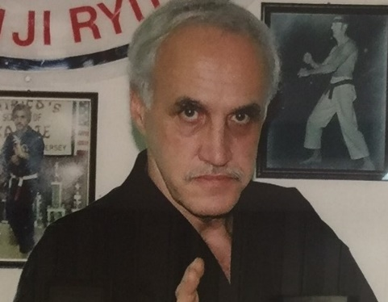

April 6. 2024

Doors Open at 8:30 AM

St. Demetrius Community Center

681-691 Roosevelt Ave., Carteret, NJ
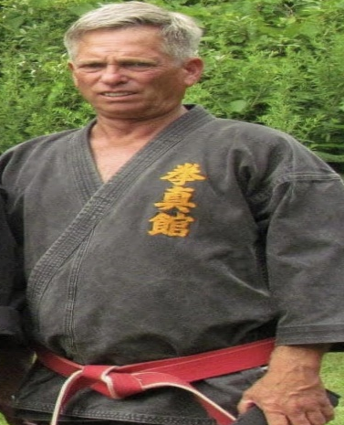
Our Friend and Brother Master Alick Smith Jr. has recently suffered a severe work-related accident which has resulted in debilitating injuries to his back. In the Spirit of Bushido, all proceeds from the 2024 Tournament will be donated to Master Alick Smith Jr to help defray his medical bills and other rehabilitation needs.
SCAN QR CODE FOR REGISTRATION AND ALL INFORMATION

